20.29: The entropy change is 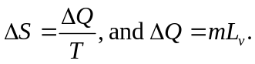 Thus,

